 

**Cookbook on**

**Remote Access Control to Sensitive Areas using Crypto Cards**

Prepared by -

**Figo Cardozo**

**Drishti Samvedi**

**Om Madat**

**Vansh Pahuja**

Under the guidance of -

**Dr. Shashi Dugad (TIFR)**

**Dr. Gresha Bhatia and Mrs. Abha Tewari (VESIT-CMPN)**

# **Table of Contents**

| **Sr No** | **Title** | **Page No** |
| --- | --- | --- |
| 1 | Introduction | 3 |
| 2 | Requirements | 3 |
| 3 | Project Files | 3 |
| 4 | Setup for NFC Card Reader ACR122U | 4 |
| 5 | Installation - Windows | 5 |
| 6 | Installation - Ubuntu | 6 |
| 7 | Running the project | 7 |
| 8 | Results | 8 |
| 9 | Contact details | 13 |

**INTRODUCTION**

Remote Access Control to Sensitive Areas using Crypto Cards is a 3-factor authentication system for granting access to sensitive areas where there is a need for high level security. The project has a user-friendly interface built using Tkinter Bootstrap that enables users to register and authenticate themselves in order to access the sensitive areas. At the backend, the system makes use of face-recognition library for face authentication, librosa library for voice recognition and pyscard for seamless integration with the NFC Smart Card Reader ACR122U.

#### 

**REQUIREMENTS**

* **Hardware:** 
  + NFC Card Reader ACR122U
  + Atleast 1K enabled NFC Smart Card
* **Software:** 
  + OS - Windows/Ubuntu/MacOS
  + Python libraries:
    - OpenCV, face-recognition, dlib, pyscard, librosa, ttkbootstrap

# **PROJECT FILES**

Download the project files from the following link and unzip the files to get the project:

#### <https://drive.google.com/drive/folders/1wDm68bDqO9FJ8aknEW_BW2Vz7WyTeQeP?usp=drive_link>

# **SETUP FOR NFC SMART CARD READER ACR122U**

**Install the Drivers:**

Download the appropriate drivers for your Windows/Ubuntu version and follow the readme files for installation of drivers from [here](http://www.acs.com.hk/en/products/3/acr122u-usb-nfc-reader/).

**Run the following commands for Ubuntu after installing the drivers:**

| **sudo apt install libnfc-bin** |
| --- |
| **sudo apt-get install libusb-1.0-0-dev** |
| **sudo apt-get install pcscd libpcsclite-dev libusb-dev** |
| **sudo apt install pcsc-tools** |
| **sudo apt-get install libccid** |
| **sudo apt-get install swig** |

**After running the above commands, check if the card reader is being detected by the system using the following command:**

| **pcsc_scan** |
| --- |

If the installation is done correctly, ACR122U card reader should be detected when the above command is executed.

# 

# **INSTALLATION-WINDOWS**

## **Python 3.8 Installation:**

Python 3.8 can be downloaded and installed from [here](https://www.python.org/downloads/) for Windows-based systems. It is already installed on Linux distros.

**Software Installation:**

1. Download venv if not present in your system using the below commands-

| **pip install virtualenv** |
| --- |

1. Open the folder path in the command prompt (Where the project has been extracted).
2. Create a virtual environment using the command

| **python -m venv <name of virtual environment>** |
| --- |

1. Activate the virtual env with the help of the following command-

| **<name of virtual environment>\scripts\activate** |
| --- |

1. Run the following command to install the dependencies (This might take some time and ensure that you have a good connection otherwise a timed out error will pop up)

| **pip install -r requirements.txt** |
| --- |

# **INSTALLATION-UBUNTU**

**Software Installation:**

1. Download venv if not present in your system using the below commands-

Note-If the below python commands don’t work, try using python and pip instead of python3 and pip3

| **sudo apt install python3-venv** |
| --- |

1. Open the folder path in the terminal (Where the project has been extracted).
2. Create a virtual environment here with the command-

| **python3 -m venv <name of virtual environment>** |
| --- |

1. Activate the virtual env with the help of the following command-

| **source <name of virtual environment>/bin/activate** |
| --- |

1. Run the following command to install the dependencies.

| **pip3 install -r requirements.txt** |
| --- |

# **RUNNING THE PROJECT**

#### **For Windows:**

| **python registration.py** |
| --- |
| **python authentication.py** |

**For ubuntu/CentOS:**

| **sudo python registration.py** |
| --- |
| **sudo python authentication.py** |

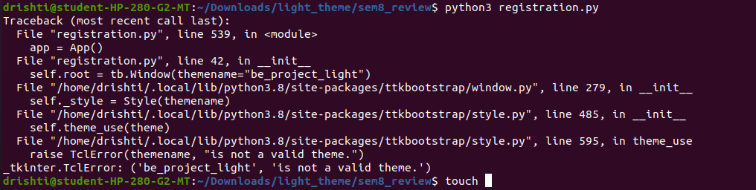

If you face the above error, it is because your virtual environment doesn’t have the customised theme of ttkbootstrap.

Copy the contents of the file user.py given in the drive and paste it in the following location in the folder -

<name of your virtaulenv>/lib/python3.8/site-packages/ttkbootstrap/themes/user.py

**RESULTS**

After successful installation the following screens will appear.

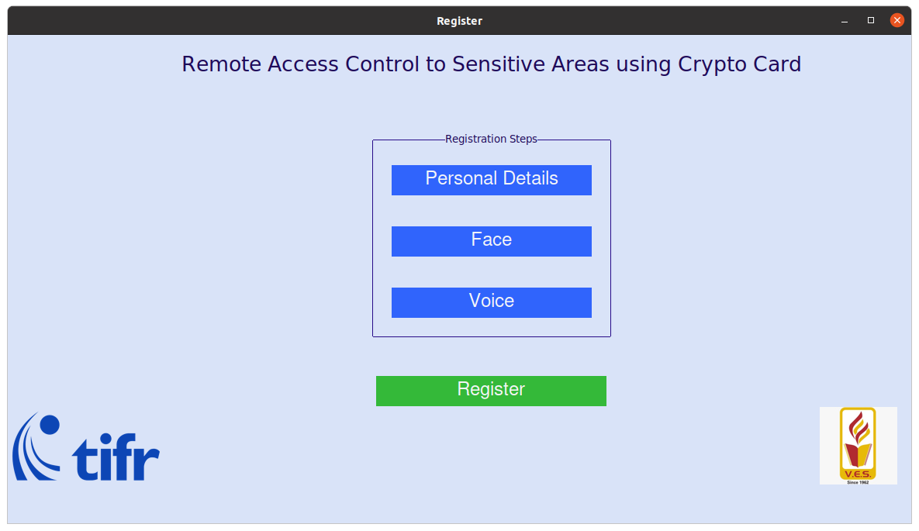

**Registration Landing Page**

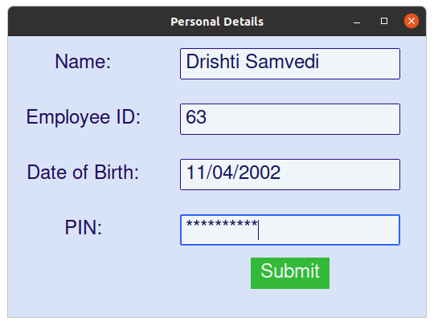

**Input Personal Details**

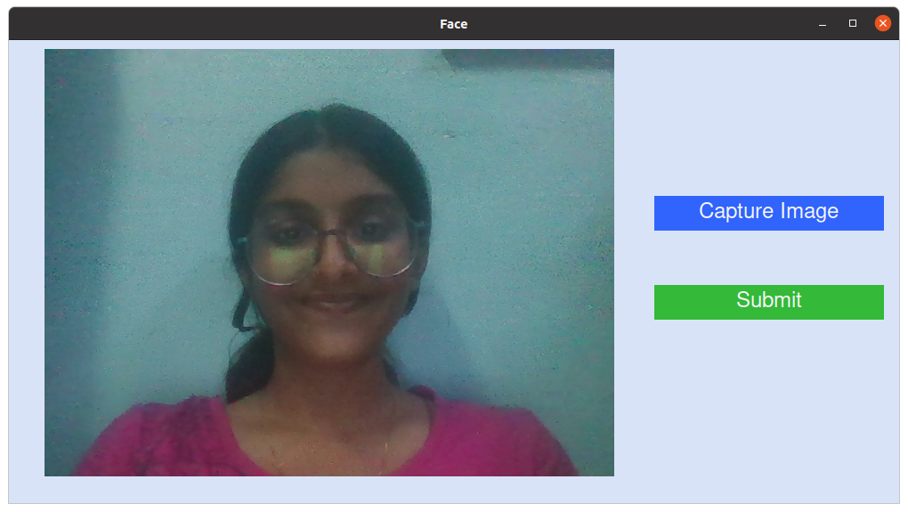

**Capture Face**

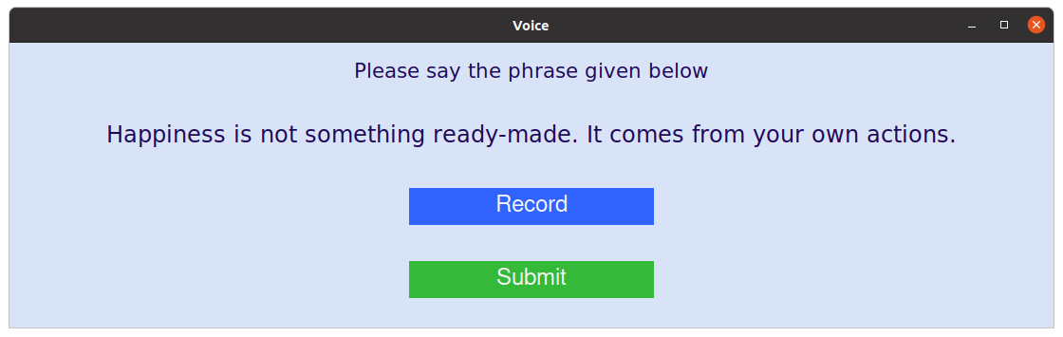

**Record Voice by saying the given phrase**

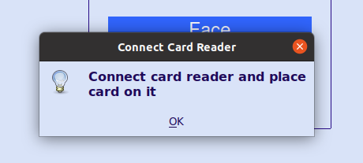

**Connect Card Reader and place the card on it**

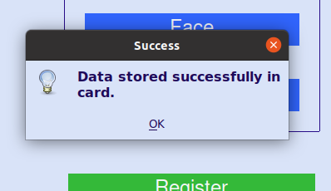

**Data will be stored in the card**

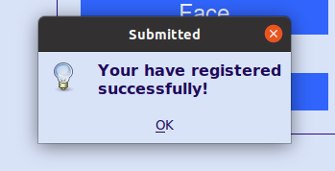

**Registration complete**

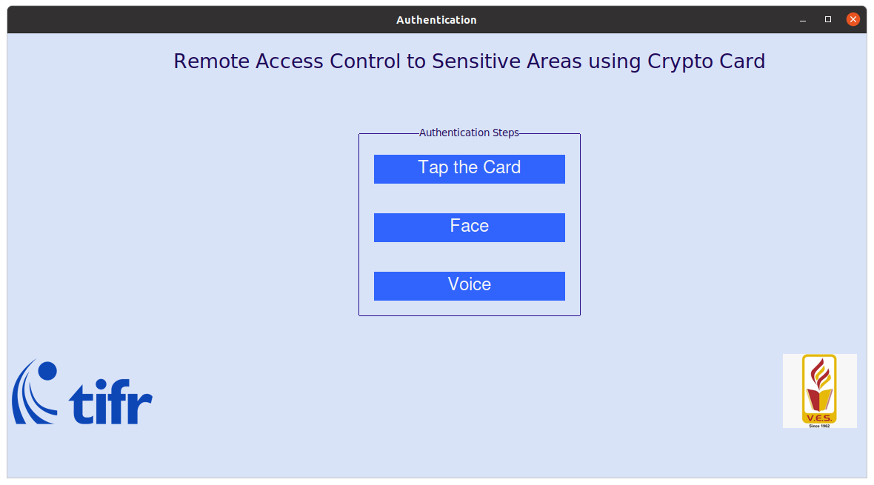

**Authentication Landing Page**

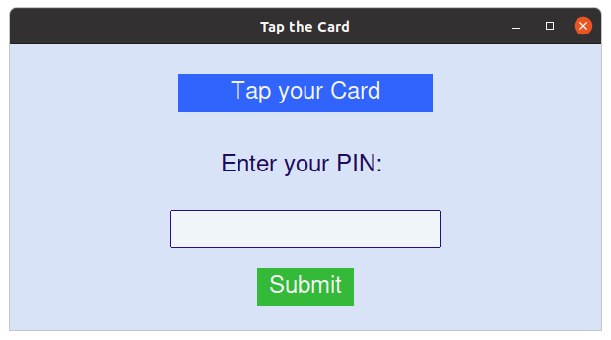

**Tap your Card on the Card Reader**

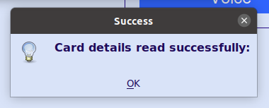

**If card details match, it will be read successfully**

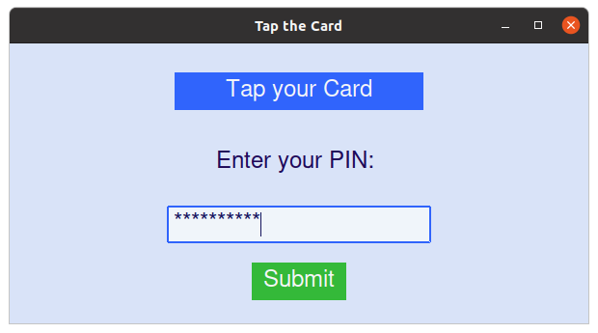

**Enter the pin**

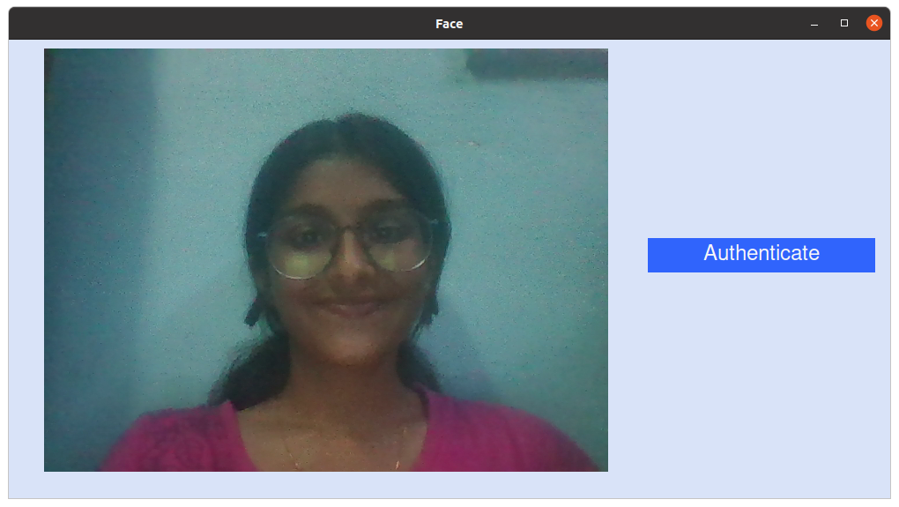

**Proceed for face authentication**

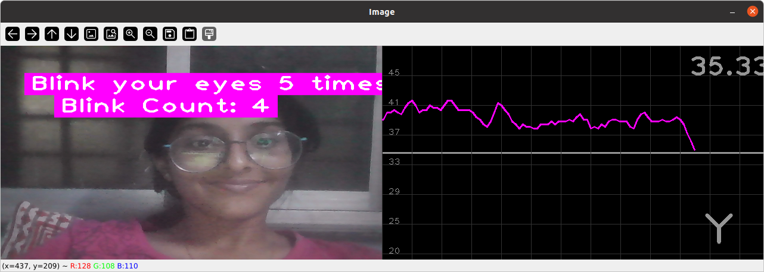

**Blink your eyes for given number of times**

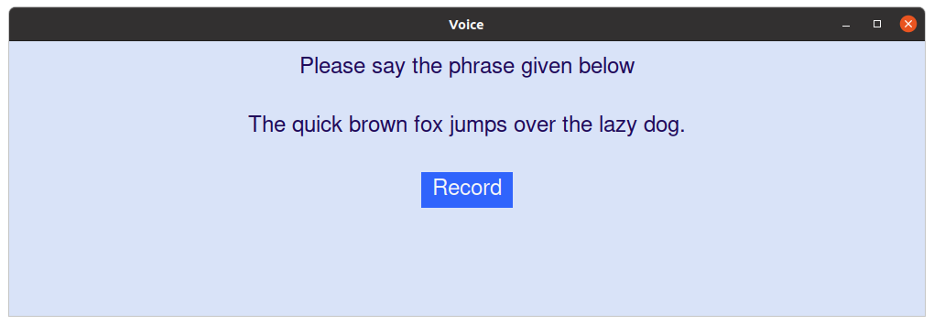

**Record your voice by saying the given phrase**

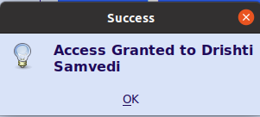

**Access will be granted if all the three factors match**

# **CONTACT DETAILS**

1. Figo Cardozo - 2020.figo.cardozo@ves.ac.in
2. Om Madat - 2020.om.madat@ves.ac.in
3. Vansh Pahuja - 2020.vansh.pahuja@ves.ac.in
4. Drishti Samvedi - 2020.drishti.samvedi@ves.ac.in